Date: 2023-05-05

ISO/DIS 13619

ISO/TC 249

Secretariat: SAC

Traditional Chinese medicine — *Gardenia jasminoides* fruit

**Copyright notice**

This ISO document is a working draft or committee draft and is copyright-protected by ISO. While the reproduction of working drafts or committee drafts in any form for use by participants in the ISO standards development process is permitted without prior permission from ISO, neither this document nor any extract from it may be reproduced, stored or transmitted in any form for any other purpose without prior written permission from ISO.

Requests for permission to reproduce this document for the purpose of selling it should be addressed as shown below or to ISO's member body in the country of the requester:

[Indicate the full address, telephone number, fax number, telex number, and electronic mail address, as appropriate, of the Copyright Manger of the ISO member body responsible for the secretariat of the TC or SC within the framework of which the working document has been prepared.]

Reproduction for sales purposes may be subject to royalty payments or a licensing agreement.

Violators may be prosecuted.

Contents Page

Foreword iv

Introduction v

1 Scope 1

2 Normative references 1

3 Terms and definitions 1

4 Descriptions 1

5 Requirements 2

6 Sampling 4

7 Test methods 4

8 Test report 5

9 Packaging, storage and transportation 5

10 Marking and labeling 5

Annex A (informative) Thin-layer chromatogram (TLC) identification 7

Annex B (informative) Determination of geniposide contents 9

Annex C (informative) Referenced information and methods for differentiating *Gardenia jasminoides* Ellis and *Gardenia* *jasminoides*var.*grandiflora* Nakai 11

Annex D (informative) Referenced information of Gardenia jasminoides fruit in different national and regional requirements 123

Bibliography 14

Foreword

ISO (the International Organization for Standardization) is a worldwide federation of national standards bodies (ISO member bodies). The work of preparing International Standards is normally carried out through ISO technical committees. Each member body interested in a subject for which a technical committee has been established has the right to be represented on that committee. International organizations, governmental and non-governmental, in liaison with ISO, also take part in the work. ISO collaborates closely with the International Electrotechnical Commission (IEC) on all matters of electrotechnical standardization.

The procedures used to develop this document and those intended for its further maintenance are described in the ISO/IEC Directives, Part 1. In particular, the different approval criteria needed for the different types of ISO document should be noted. This document was drafted in accordance with the editorial rules of the ISO/IEC Directives, Part 2 (see [www.iso.org/directives](https://www.iso.org/directives-and-policies.html)).

ISO draws attention to the possibility that the implementation of this document may involve the use of (a) patent(s). ISO takes no position concerning the evidence, validity or applicability of any claimed patent rights in respect thereof. As of the date of publication of this document, ISO had not received notice of (a) patent(s) which may be required to implement this document. However, implementers are cautioned that this may not represent the latest information, which may be obtained from the patent database available at [www.iso.org/patents](http://www.iso.org/patents). ISO shall not be held responsible for identifying any or all such patent rights.

Any trade name used in this document is information given for the convenience of users and does not constitute an endorsement.

For an explanation of the voluntary nature of standards, the meaning of ISO specific terms and expressions related to conformity assessment, as well as information about ISO's adherence to the World Trade Organization (WTO) principles in the Technical Barriers to Trade (TBT), see [www.iso.org/iso/foreword.html](https://www.iso.org/foreword-supplementary-information.html).

This document was prepared by Technical Committee ISO/TC 249, *Traditional Chinese medicine*.

Any feedback or questions on this document should be directed to the user’s national standards body. A complete listing of these bodies can be found at [www.iso.org/members.html](https://www.iso.org/members.html).

Introduction

*Gardenia jasminoides* fruit, the dried fruit of *Gardenia jasminoides* Ellis (Fam. Rubiaceae), is widely used in China, Japan, Korea, other Southeast Asian countries and North America, and has a long application history as herbal medicine. It is commonly used for draining fire and treatment of certain febrile conditions, cooling blood and eliminating stasis to activate blood circulation. Clinically, owing to its medicinal properties, it plays an important role in diuretic, cholagogue, anti-inflammatory, antioxidant and antipyretic effects.

*G. jasminoides* fruit has also been applied as an important natural colourant, such as gardenia yellow and gardenia blue pigments in China, Japan, Korea, India and North America. Recently, there has been an increasing demand for *G. jasminoides* fruit in China and elsewhere; the average annual demand for *G. jasminoides* fruit between 2015 and 2020 was about 1 500 tons. *G. jasminoides* fruit is ranked no. 59 in the priority list of single herbal medicines for developing standards in ISO 23975.

*G. jasminoides* fruit has been widely cultivated as a medicinal and ornamental plant in the tropical and subtropical regions of the world, growing on mountain slopes or at the roadside. However, the quality of *G. jasminoides* fruit provided from different areas or by different cultivators is quite different. In addition, though *G. jasminoides* fruit has been recorded in several pharmacopeias and standards, specifications and quality requirements in these standards vary. Thus, there is a clear and urgent need to develop an International Standard for harmonizing these existing standards, as well as ensuring the safety and effectiveness of *G. jasminoides* fruit.

As national implementation can differ, national standards bodies are invited to modify the values given in 5.4 and 5.5 in their national standards. Examples of national and regional values are given in Annex D.

Traditional Chinese medicine — *Gardenia jasminoides* fruit

# Scope

This document specifies the quality and safety requirements and test methods of *Gardenia jasminoides* fruit, which is derived from the dried fruit of *Gardenia jasminoides* Ellis (Fam. Rubiaceae).

This document is applicable to *Gardenia jasminoides* fruit that are sold and used as natural medicines in international trade, including Chinese materia medica (whole medicinal material) and decoction pieces derived from this plant.

# Normative references

The following documents are referred to in the text in such a way that some or all of their content constitutes requirements of this document. For dated references, only the edition cited applies. For undated references, the latest edition of the referenced document (including any amendments) applies.

ISO 18664, Traditional Chinese Medicine — Determination of heavy metals in herbal medicines used in Traditional Chinese Medicine

ISO/TS 21310, Traditional Chinese medicine — Microscopic examination of medicinal herbs

ISO 22217, Traditional Chinese medicine —Storage requirements for raw materials and decoction pieces

ISO 22258, Traditional Chinese medicine — Determination of pesticide residues in natural products by gas chromatography

ISO 23723:2021, Traditional Chinese medicine — General requirements for herbal raw material and materia medica

# Terms and definitions

For the purposes of this document, the following terms and definitions apply.

ISO and IEC maintain terminology databases for use in standardization at the following addresses:

— ISO Online browsing platform: available at [https://www.iso.org/obp](https://www.iso.org/obp/ui)

— IEC Electropedia: available at <https://www.electropedia.org/>

3.1

*Gardenia jasminoides* fruit

dried ripe fruit of *Gardenia jasminoides* Ellis (Fam. Rubiaceae)

# Descriptions

In this document, the structure of *Gardenia jasminoides* Ellis and the dried ripe fruit are shown in Figure 1. Different features such as leaves, flowers and fruits in *Gardenia jasminoides* Ellis *and Gardenia jasminoides var. grandiflora* Nakai, and methods for differentiating these two species, are given in Annex C.

|  |  |
| --- | --- |
|  |  |
| **a) Plant part of *Gardenia jasminoides* Ellis** | **b) Dried ripe *Gardenia jasminoides* fruit** |

Key

|  |  |
| --- | --- |
| 1 | fruiting branch |
| 2 | flowering branch |
| 3 | corolla and calyx |
| 4 | peduncle |
| 5 | persistent calyx |
| 6 | length |
| 7 | diameter |

Figure 1 — Structure of the plant part and fruit of *Gardenia jasminoides* Ellis

# Requirements

## General

The following requirements shall be met before the sampling (see Clause 6):

a) *Gardenia jasminoides* fruit shall be clean and free from leaves, stems and foreign matter;

b) The presence of living inserts, mouldy fruit and external contaiminants which are visible to the naked eye shall not be permitted.

## Morphological features

### Appearance

The fruit is ovate to long ovate or elliptical (see Figure 1 b). The external fruit surface usually has six antesepalous raised and longitudinal winged ridges. The basally gamosepalous persistent calyx (key 5) or its scar are visible at the upper end of the fruit, and sometimes has the peduncle (key 4) remaining at the lower end of the fruit. The inner surface of pericarp is brittle, smooth and lustrous, and is internally divided into two or three rows of protruding membrances, which contain seeds.

### Colour

The smooth or slightly rough outer surface is yellowish, reddish-yellow or brownish-red. The pericarp has a pale yellow or brownish-yellow inner surface.

### Dimensions

The fruit is 15 mm to 35 mm in length measured from the base to the end of the fruit, and 10 mm to 15 mm in diameter measured at the middle of the fruit.

### Fracture

The pericarp is thin and easily broken. The seeds are flattened ovate, with several seeds gathered together to form masses. They are deep red or yellow-red, with a dense arrangement of thin, small strumae on the external surface.

### Odour and taste

The odour is slight and characteristic and the taste is bitter.

## Microscopical characteristics

As shown in Figure 2, the powder is reddish-brown or yellow-brown; sclereid of endocarp (key 1) is subrounded or polygonal, about 17 μm to 31 μm in diameter, with thickened walls and lumina containing crystals of calcium oxalates about 8 μm in diameter; fragments of mesocarp consist of thin-walled parenchymastous cells associated with fibres and yellowish spiral or annular vessels (key 2); endocarp fibres (key 3) are long and thin, about 10 μm in diameter and up to 100 μm long, obliquely mosaic-arranged; fragements of testa consist of largely irregularly shaped sclereids (key 4), 58 μm to 150 μm in diameter and up to 260 μm long, with irregularly thickened yellowish walls, wide pits and containing a reddish-brown substance; and endosperm with cells containing scattered clusters of calcium oxalate (key 5).

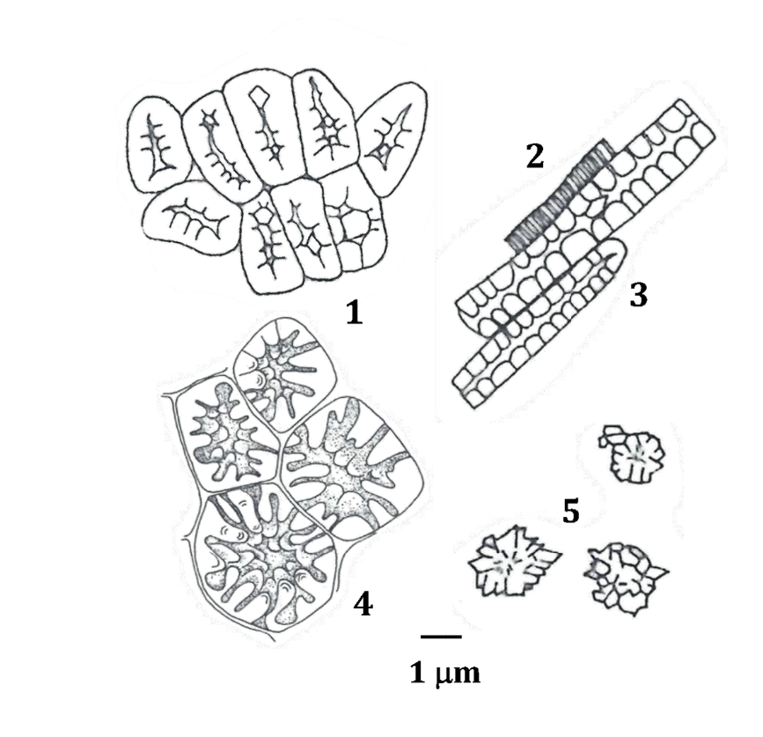

Key

|  |  |
| --- | --- |
| 1 | sclereid of endocarp |
| 2 | annular vessel |
| 3 | endocarp fibre |
| 4 | sclereid of testa |
| 5 | calcium oxalate |

Figure 2 — Microscopical characteristics of *Gardenia jsaminoides* fruit powder

## Moisture

The moisture content should not be more than a mass fraction of 13,0%.

## Total ash

The total ash content should not be more than a mass fraction of 6,0%.

## Thin-layer chromatogram (TLC) identification

The identification of extracts of *Gardenia jasminoides* fruit with thin-layer chromatogram (TLC) should present the spot or band with the same colour and position as those of the reference solution.

## Marker compound(s)

The content of marker compounds, such as geniposide (C17H24O10), should be determined.

## Heavy metals

The contents of heavy metals, such as arsenic, mercury, lead and cadmium, should be determined.

## Pesticide residues

The contents of pesticide residues, such as DDT, endrin, BHC, aldrin and dieldrin, shall be determined.

# Sampling

Sampling of *Gaedenia jasminoides* fruit shall be carried out in accordance with Clause 8 of ISO 23723.

# Test methods

## Macroscopic identification

Samples of not less than 500 g are taken from each batch randomly. These samples are examinated with the naked eye in sunlight, smelled and tasted.

## Microscopical identification

The testing method specified in ISO/TS 21310 shall apply.

## Determination of moisture content

The testing method specified in the Clause 7.2.3 of ISO 23723 shall apply.

## Determination of total ash content

The testing method specified in the Clause 7.2.3 of ISO 23723 shall apply.

## Thin-layer chromatogram (TLC) identification

See Annex A for additional information.

## Determination of marker compound(s)

See Annex B for additional information.

## Determination of heavy metal contents

The testing method specified in ISO 18664 shall apply.

## Determination of pesticide residue contents

The testing method specified in ISO 22258 shall apply.

# Test report

For each test method, the test report shall specify the following:

a) all information necessary for the complete identification of the sample;

b) the sampling method used;

c) the test method used, with reference to this document;

d) the test result(s) obtained;

e) all operating details not specified in this document or regarded as optional, together with details of any incidents which could have influenced the test result(s);

f) any unusual features (anomalies) observed during the test;

g) the date of the test.

# Packaging, storage and transportation

The packaging and transportation shall not transmit any odour or flavour to the product and shall not contain substances which could damage the product or constitute a health risk. The packaging shall be strong enough to withstand normal handling and transportation.

The storage requirements for *Gardenia jasminoides* fruit shall refer to ISO 22217.

The products shall be protected from light, moisture, pollution and entry of foreign substances during long-distance delivery. Carriers should be well ventilated to keep dry and moisture-proof.

# Marking and labeling

See the method specified in ISO 21371. The following items shall be marked or labeled on the packages:

a) all quality features indicated in Clause 5, determined in accordance with the methods specified in Clause 7;

b) gross weight and net weight of the package;

c) country and province or state of origin of the products;

d) date of production and expiry date of the products;

e) storage method;

f) any items required by regulatory bodies of destination country.

1. (informative)  
     
   Thin-layer chromatogram (TLC) identification
   1. Preparation of test solution

Weigh 1.0 g of sample to grind and pass it through a 24-mesh or coarse sieve, add 50 ml 50% methanol and extract with ultrasonic for 30 min, filter and use the filtered solution as the test solution.

* 1. Preparation of reference drug solution

Weigh 1.0 g of reference drug of *Gardenia jasminoids* fruit to grind and pass it through a 24-mesh or coarse sieve. Treat it in the same manner as the reference drug solution in A.1.

* 1. Preparation of reference substance solution

Dissolve a quantity of geniposide CRS with ethanol in a brown cliometric flask to produce a solution containing 4.0 mg of each per ml as the reference solution.

* 1. Developing solvent system

Prepare a mixture of ehtyl acetate–acetone–formic acid–water (volume ratio 5:5:5:1) as the mobile phase.

* 1. Procedure

Apply 2.0 μl each of the reference drug solution and the test solutions on the same TLC plate (silical gel G) previously dried at 110°C for 15 min in the oven. Develop the plate in the mobile phase decribed in A.4, then move the plate and dry in air for determination of the colour of spots. Subsquently, examine the plate under spraying with 10% suifuric acid ethanol solution, then heat at 110°C until spots appear clearly. Identify the spots of the test solutions by comparing the positions and colours with those of the reference drug solution.

Typical reference TLCs are shown in Figure A.1.

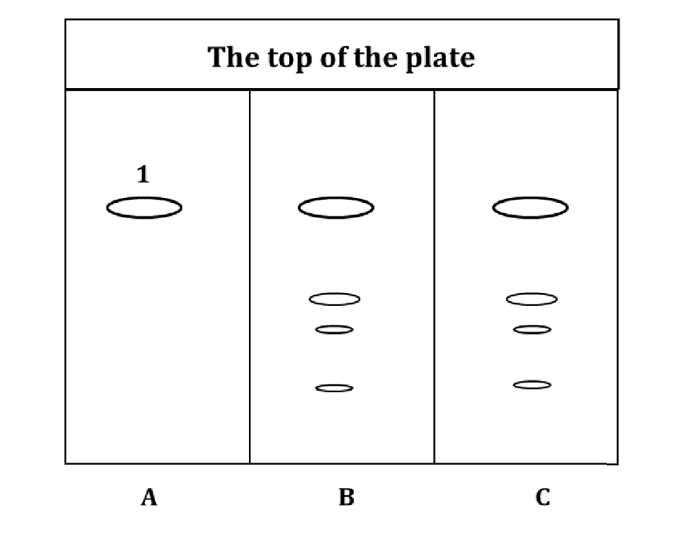

Key

|  |  |
| --- | --- |
| 1 | geniposide |
| A | reference solution |
| B | *Gardenia jasminoids* fruit reference drug solution |
| C | *Gardenia jasminoids* fruit test solution |

Figure A.1 —Schematic diagram of typical TLC of *Gardenia jasminoides* fruit

1. (informative)  
     
   Determination of geniposide contents
   1. Principle of the test method

The high-performance liquid chromatography (HPLC) method is employed to determine the content of geniposide. The HPLC system consists of a quaternary pump, continuous vacuum degasser, thermostated auto-sampler and column compartment coupled to a variable wavelength diode-array detector.

* 1. Preparation of reference standard solution

Dissolve a quantity of geniposide CRS with ethanol in a brown cliometric flask to produce a solution containing 0,3 mg of each per ml as the reference solution.

* 1. Preparation of test solution

Weigh 250 g of sample to grind and pass it through an 80-mesh sieve. Weigh accurately 0,1 g of the powder in a stopper conical flask. Accurately add 25 ml of methanol. Weigh and extract under ulsutronic for 20 min. Cool and weigh again. Replenish the loss of mass with methanol and mix well. Filter and use the successive filtrate. Pipet 10 ml of the filtrate, add methanol to make exactly 25 ml and use this solution as the final test solution. Filter the supernatant through a 0,45 μm Millipore filter unit before HPLC analysis.

* 1. Chromatographic system

Column:

a) Stationary phase: octadecylsilane bonded silica gel as analysing column or equivalent.

b) Size: *l* = 250 mm, *Φ* = 4,6 mm.

c) Theoretical plates: not less than 1 500.

Mobile phase:

1) Mobile phase A: water of chromatography grade.

2) Mobile phase B: acetonitrile of chromatography grade.

3) Isocratic elution: a mixture of mobile phases A and B (85:15).

Flow rate: 1,0 ml/min.

Detector: 238 nm.

Column temperature: 30 °C.

Injection volume: 10 μl.

* 1. Content calculation of geniposide

The content of geniposide, *C*gen (%), is calculated with Formula C.1.

 (C.1)

where

|  |  |  |
| --- | --- | --- |
|  | *C*s | is the average content of the sample (mg/ml); |
|  | *m* | is the mass of *Gardenia jasminoides* fruit taken to prepare the sample solution (g); |
|  | *C*m | is the moisture content of the sample (%). |

A typical reference HPLC chromatogram is shown in Figure B.1.

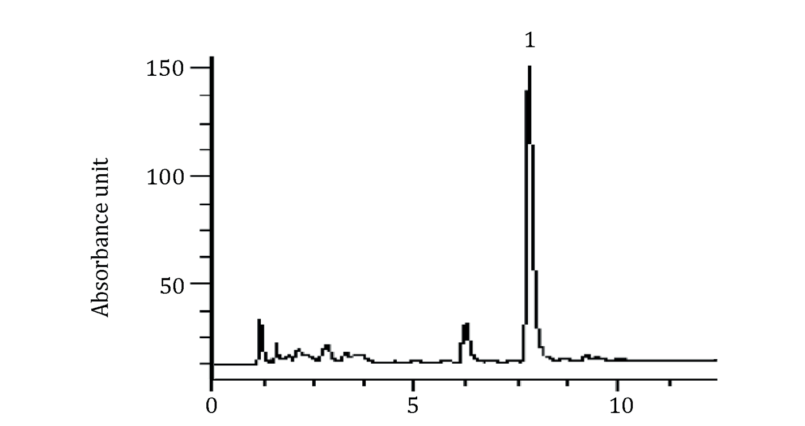

Key

|  |  |
| --- | --- |
| 1 | Geniposide |

Figure B.1 —Typical HPLC chromatograms of *Gardenia jasminoides* fruit

1. (informative)  
     
   Referenced information and methods for differentiating *Gardenia jasminoides* Ellis and *Gardenia* *jasminoides* var. *grandiflora* Nakai

Different features, such as leaves, flowers and fruit, of *Gardenia jasminoides* Ellis *and Gardenia jasminoides var. grandiflora* Nakai, and methods for differentiating these two species, are shown in Table C.1.

Table C.1 — Reference information and methods for differentiating *Gardenia jasminoides* Ellis and *Gardenia jasminoides var. grandiflora* Nakai[5]

|  |  |  |  |
| --- | --- | --- | --- |
| **Items** | | ***G. jasminoides* Ellis**  **(Mountain-*Gardenia jasminoides* fruit)** | ***G. jasminoides* var. *grandiflora* Nakai**  **(Water-*Gardenia jasminoides* fruit)** |
| Morphological features | Leaves | Oblong-lanceolate or broad-lanceolate  Length: 5,0 cm to 11,0 cm | Oblong-lanceolate or ovate-lanceolate  Length: 7,0 cm to 14,0 cm |
| Flowers | Smaller; diameter ≤ 7,0 cm | Bigger; diameter ≥ 7,0 cm |
| Fruit | Length: 1,5 cm to 3,5 cm  Diameter: 1,0 cm to 1,5 cm | Length: 3,0 cm to 7,0 cm  Diameter: 1,0 cm to 1,5 cm |
| Application | | Medicinal use | Ornamental, natural edible pigments |
| Methods for  differentiating | | Random amplified polymorphic DNA (RAPD) | |

1. (informative)  
     
   National and regional requirements for *Gardenia jasminoides* fruit

Examples of different national and regional quality requirements for *Gardenia jasminoides* fruit are shown in Table D.1.

Table D.1 — National and regional quality requirements for *Gardenia jasminoides* fruit

|  |  |  |  |  |  |
| --- | --- | --- | --- | --- | --- |
| **Items** | | **Authority regulation** | | | |
| **Pharmacopoeia of the People's Republic of China**[1] | **European  Pharmacopoeia**[4] | **Japanese  Pharmacopoeia**[2] | **Korean  Pharmacopoeia**[3] |
| Plant origin | | *Gardenia jasminoides* Ellis | *Gardenia jasminoides* Ellis | *Gardenia jasminoides* Ellis | *Gardenia jasminoides* Ellis |
| Identification | Description | √ | √ | √ | √ |
| Microscopy | √ | √ | √ | √ |
| TLC | √ | √ | √ | √ |
| Examination | Moisture | ≤ 8,5 % | ≤ 8,5 % | ≤ 13,0 % | ≤ 10,0 % |
| Total ash | ≤ 6,0 % | ≤ 6,0 % | ≤ 6,0 % | ≤ 6,0 % |
| Heavy metals | Lead | ≤ 5,0 mg/kg | ≤ 5,0 ppm | − | ≤ 5,0 ppm |
| Cadmium | ≤ 1,0 mg/kg | ≤ 1,0 ppm | ≤ 0,3 ppm |
| Mercury | ≤ 0,2 mg/kg | ≤ 0,1 ppm | ≤ 0,2 ppm |
| Arsenic | ≤ 2,0 mg/kg | − | ≤ 3,0 ppm |
| Residual pesticides | Total DDT | 33 kinds of pesticide residues, such as DDT, BHC and Endrin shall be detected | ≤ 1,0 ppm | − | ≤ 0,1 ppm |
| Endrin | ≤ 0,05 ppm | − | ≤ 0,01 ppm |
| Total BHC | − | − | ≤ 0,2 ppm |
| Aldrin | ≤ 0,05 ppm | − | ≤ 0,01 ppm |
| Dieldrin | − | ≤ 0,01 ppm |
| Assay | Geniposide | ≥ 1,8 % | ≥ 2,0 % | ≥ 2,7 % | ≥ 3,0 % |
| **Key**  √   index is set in the pharmacopeia  −   index is not set in the pharmacopeia | | | | | |

Bibliography

[1] China Pharmacopoeia Commission. *Pharmacopoeia of the People's Republic of China (2020 edition, Part 1)*. Beijing: Chinese medicines and Technology Press, 2020

[2] Committee on Japanese pharmacopoeia. *The Japanese Pharmacopoeia* (*18th edition)*. Tokyo: Ministry of Health, Labour and Welfare, 2021

[3] Ministry of Food and Drug Safety. *The Korean Pharmacopoeia (12th edition)*. Chungcheong Bukdo: The Ministry of Food and Drug Safety, 2019

[4] European Pharmacopoeia Commission. *European Pharmacopoeia* *(10th edition)*. Strasbourg: European Directorate for the Quality of Medicines & Health Care, 2019

[5] Mei Z., Zhou B., Wei C., Cheng J., Imani S., Chen H., Fu J. Genetic authentication of *Gardenia jasminoides* Ellis var. *grandiflora* Nakai by improved RAPD-derived DNA markers. *Molecules*. 2015, 20(11) pp. 20219